ObjectListDataProvider Integration for ICEfaces

Thesis Proposal
For the degree of Master of Science in Computer Science
At Southern Connecticut State University
Jason Williams
Thesis Advisor: Dr. Podnar

Major-Field Approval – The advisor and the department chairperson
______________________ ____________________
Advisor Date
______________________ ____________________
Chairperson Date
A. Title
ObjectListDataProvider Integration for ICEfaces
B. Statement of Purpose
Web 2.0 technologies such as Java Server Faces (JSF) provide feature-rich, standardized frameworks for dependable, fast web application development. These technologies can be used from within an Integrated Development Environment (IDE) in a fashion that provides a drag and drop, intuitive means of creating pages that can be utilized by developers without the skills necessary to write these applications from scratch. This allows for fast prototyping and development cycles adding productivity to teams creating web applications. JSF is a popular choice for development as previously described and is advertised as having the features listed below.
JSF Features [1]
- A standard component API for specifying the state and behavior of a wide range of components, including simple components, such as input fields, and more complex components, such as scrollable data tables. Developers can also create their own components based on these APIs, and many third parties have already done so and have made their component libraries publicly available.
- A separate rendering model that defines how to render the components in various ways. For example, a component used for selecting an item from a list can be rendered as a menu or a set of radio buttons.
- An event and listener model that defines how to handle events generated by activating a component, such as what to do when a user clicks a button.
- Conversion and validation models for converting and validating component data.

While JSF itself is a framework, it has complementary component kits that run on top of it providing extensible, reusable, and useful components. Sun RI (2002-2007), later replaced by Project Woodstock (2006-2009) is the component kit developed my Sun Microsystems and integrated into the NetBeans IDE which is a widely used platform for web application development. Over the past several years, developers made use of this platform suite to develop web applications using Woodstock and JSF. Though JSF itself is standardized and utilizes a write once, run anywhere approach, the component kits that run on it are not (with the exception of the very basic standard components). Due to difficulties faced by Sun, the Woodstock Project has been shelved and developers dependent on it are being officially directed by Sun to migrate to IceSoft Technologies ICEfaces. While much of the porting required to make this transition is relatively straightforward, some components such as tables will require extensive rework, replacement, or removal without a suitable means of making them compatible. This project intends to bridge that gap by developing middleware that will interface the existing Woodstock data model with the front end JSF used in ICEfaces.
C. Literature Review and Current State-Of-The-Art
Sun Microsystems’s JSF provides a framework for building server side interfaces for Web Applications. This framework is designed to provide ease of use, standardization, and device independence which all combine to enhance the productivity of developers working on Java 2 Enterprise Edition (J2EE) web applications. The API provides reusable components in a web page, event handling for page actions, and integration with data sources. The API and methodology details of JSF can be found in the following Java Specification Request, JSR-252.
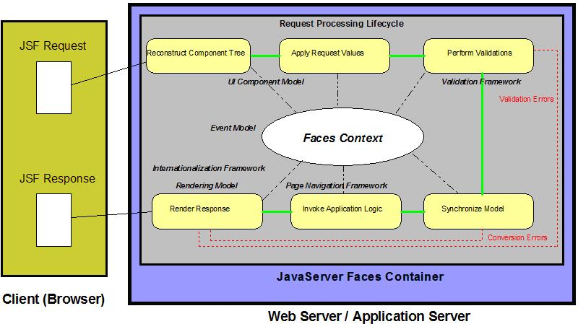
Figure 1 (JSF Lifecycle)

While JSF provides a standard API for the basic implementation of the framework, different component kits are used to provide the actual rendering of the features the user will interact with on the web page itself. For example, a button on a page or password input field are examples of page components or widgets. Sun originally began packaging JSF 1.1 with its own component kit Sun Reference Implementation (Sun RI) with the Java Studio Creator Integrated Development Environment (IDE). This development environment made it possible to create web pages using a drag and drop Graphical User Interface (GUI) editor quickly and effortlessly. As development of these technologies progressed, JSF 1.2 was integrated into the NetBeans 6.0 IDE and SUN RI was transitioned to Project Woodstock. Project Woodstock was a more advanced version of Sun RI that took advantage of client side rendering and Asynchronous JavaScript with XML (Ajax) technologies. Using the NetBeans IDE, developers could create web applications with advanced features such as auto-complete, charts, graphs, and calendars. These advanced components were all a part of the component kit and provided JSF developers with the ability to create powerful, feature rich web applications.
Unfortunately, ever since the Dot-com boom of the late 90’s, Sun Microsystems has been a company in financial trouble. This difficulty became more burdensome during the credit crisis experienced in the fall of 2008. Presently, Sun’s deteriorated financial state forced it to find a buyer (Oracle Corporation) and is currently in the process of being acquired. This coupled with a sharp increase in borrowing costs forced Sun to make severe cutbacks in 2008 and 2009. This meant that projects such as Project Woodstock would be scrapped and future development would be cancelled. While these technologies are open source, they tend to not survive when active corporate development and maintenance is not being performed on them. This means that Project Woodstock is effectively dead in the water. The impact on users of Project Woodstock is quite severe in that they will have some decisions to make regarding where to go from here with their current projects and future development work.
There are several possibilities for current users of Project Woodstock. One option is to continue on using the Woodstock component kit as is and accept the limitations it currently has. This will be problematic in the future because subsequent versions of the NetBeans IDE will not support Woodstock and any problems experienced using future browser versions will not be resolved. Another option is for someone to take over development and maintenance of Woodstock. Since the project is open source this is a possibility. The obvious drawback of this is that there are very few individuals or IT shops with the resources available to take on this project while also performing their other activities. The final and most likely option is to follow Sun’s guidance and move to their recommended replacement for Project Woodstock, IceSoft Technologies’ ICEfaces.
ICEfaces are another JSF component kit that previously competed with Woodstock and like Woodstock, are open source. ICEfaces also have many different feature rich components and rely heavily on Ajax to deliver desktop like look and feel to web based application. IceSoft Technologies is providing a NetBeans integration component to allow for the same drag and drop ease of development for ICEfaces that Woodstock developers enjoyed. IceSoft is also creating GUI development environments for many other IDE’s. Because, ICEfaces are the chosen replacement for Woodstock, IceSoft is providing tutorials and mappings for porting over components from one technology to the other. Since both component kits run on the same framework, JSF 1.2, much of the underlying Java code when it comes to things like event handling, navigation, data access, and more will not need to be modified whatsoever. However, some of components are not completely compatible and will require some Java coding changes. In any event, the presentation layer (JSP Java Server Page) will require complete porting over to ICEfaces in order to transition the application. Since the component kit has changed, all of the JSP tags in the old Woodstock namespace will be migrated over to their corresponding component tag in the ICEfaces namespace. For most of the simple widgets, this will require nothing more than simply changing the name of the tag in the JSP page. An example chart of the mapping from Woodstock to ICEfaces is below.
 |  | Woodstock | ICEfaces | Details
Basic
Label |  | webuijsf:label | ice:outputLabel | Details
Static Text |  | webuijsf:staticText | ice:outputText | Details
Text Field |  | webuijsf:textField | ice:inputText | Details
Text Area |  | webuijsf:textArea | ice:inputTextArea | Details
Editable Field |  | webuijsf:editableField | none | Coming Soon
Editable List |  | webuijsf:editableList | none | Details
Checkbox Group |  | webuijsf:checkboxGroup | ice:selectManyCheckbox | Details
Radio Button |  | webuijsf:radioButton | ice:radio | Details
Radio Button Group |  | webuijsf:radioButtonGroup | ice:selectOneRadio | Details
… |  | … | … | …
Table |  | webuijsf:table | ice:dataTable | Details
Table Column |  | webuijsf:tableColumn | ice:column | Details
Table Row Group |  | webuijsf:tableRowGroup | none | Coming Soon
… |  | … | … | …
Rating |  | webuijsf:rating | none | Coming Soon
Script |  | webuijsf:script | none | Coming Soon
(Table 1)
As it can be seen from Table 1, while most components are supported and can be ported directly, some components are not present in ICEfaces and therefore, they need to be removed, redesigned, or replaced.
Among the many companies currently utilizing Project Woodstock for active development is 3M Health Information Systems (3M HIS). 3M HIS develops claims possessing software for federal and state governments along with tools for hospitals. This company uses cutting edge technologies such as JSF for purposes such as developing web front ends to content management tools, and external facing client testing tools. They have about 10 developers working on over 20 web applications developed with Woodstock. After analyzing several of 3M HIS’s web applications it becomes clear that many of the components used will port to ICEfaces directly without many code changes and without a large commitment of resources.
There is one glaring exception to these portability findings. The use of tables is quite extensive in most of the applications examined. While there is a direct mapping for the table itself, many of the features and implementation of the table component differ significantly between the two component kits. Since some applications contain several tables and tables are used in a myriad of different ways, using ICEfaces suggestion of replacing the tables with ICEfaces tables [2] would prove to be a large commitment of resources. This proves to be undesirable to 3M HIS and many other companies and individuals looking to port their components.
There are several potential issues that will be faced by the developer when it comes to porting tables. First and foremost, the underlying data models for the tables themselves are different making them fundamentally incompatible. Also the concept of a Table Row Group that was found in the Woodstock table is nonexistent in ICEfaces. The methods used to sort the table and split it into multiple sections (pagination) differ significantly.
Developers have already invested significant time and effort into building data providers for the old SUN RI component kit and for the Woodstock component kit. These data providers would have to be abandoned and rewritten in order to run on ICEfaces.
D. Methodology
A bridge needs to be written that will allow legacy Woodstock applications to more easily port to ICEfaces. This bridge would allow tables with the underlying data model ObjectListDataProvider, which was previously used for Sun RI and Woodstock, to run in ICEfaces. This bridge would essentially be a piece of middleware that transforms the Sun data provider into something compatible with ICEfaces. This would make it such that developers of Woodstock web applications could port their existing applications to ICEfaces without sacrificing the hard work that went into designing and implementing the table logic. The figure below (Figure 2) is a graphical representation of the proposed solution.
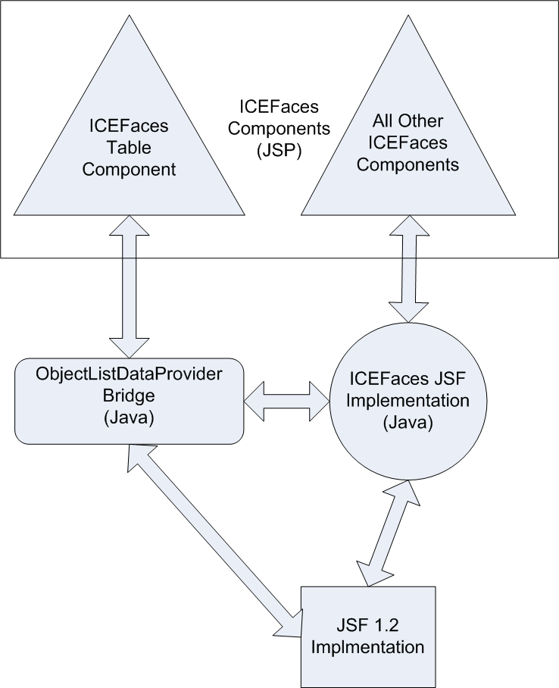
(Figure 2)
The existing logic for pagination and sorting in a Woodstock table was essentially part of the component in that the developer did not have to code any of it if they were not looking to override the standard behavior. This would suggest that even if the developer could use their existing data model for the backend source of the table, they would still need to code the pagination and sorting portions of the table if they were utilizing those capabilities previously. This obstacle can also be overcome by implementing the previously existing, standard behavior in the middleware to be written.
Another pitfall of conversion to ICEfaces is the lack of support for the TableRowGroup concept. The TableRowGroup is used heavily to perform functions like selection particular rows with checkboxes or radio buttons. This feature will also have to be bridged in order to maintain the existing functionality of selectable tables. The TableRowGroup also has the capability of committing changes made to tables with editable components such as text fields and dropdown lists. Those changes are then passed onto the underlying data model objects. The bridge will have to perform this function in a seamless manner in addition to being able to perform the complementary function of rolling back.
To develop this bridge, the sources of Woodstock, ICEfaces, and JSF will have to be studied and understood. The approach used to make the two technologies compatible will need to be designed and coded. Thorough testing will need to be performed and all existing table functions will need to be verified. Documentation for the use of the bridge will need to be created and this should all be added back to the open source community.
E. Contributions
This work will be useful to anyone looking to port their legacy Woodstock web applications over to ICEfaces assuming they used tables. This would save countless hours and resource allocations of many individual programmers and companies that had made a commitment to Woodstock that are now faced with the task of porting their code. This will also provide technical steering committees with an additional option to choose when deciding where they must go from here.
While the benefit to the J2EE community is fairly obvious, it will not be realized without proper examples and documentation. Such materials should be produced during the course of this project.
F. References

[1] “ICEFaces Main Page”, IceSoft Technologies INC., IceSoft Technologies, April 2009. [Online]
Available: http://www.icefaces.org/main/home/ [Retrieved April 2009]

[2] B.Dudney, J. Lehr, B. Willis, and L. Mattingly, Mastering JavaServer Faces, Indianapolis, Indiana, Wiley Publishing Inc., 2004

[3] “Woodstock to ICEFaces Porting Guide”, IceSoft Technologies, April 2009. [Online]
Available: http://facestutorials.icefaces.org/tutorial/woodstock/PortingGuidePart2.html [Retrieved April 2009]

[4] “Sun JavaServer Faces Technology”, Sun Microsystems, April 2009. [Online]
Available: http://java.sun.com/javaee/javaserverfaces/ [Retrieved April 2009]

[5] N. Feras, “ICEfaces Evolves Integration with NetBeans IDE and GlassFish Providing Migration Path for "Project Woodstock" JSF Components”, NewGuide.us, April 2009. [Online]
Available: http://www.newsguide.us/technology/information/ICEfaces-Evolves-Integration-with-NetBeans-IDE-and-GlassFish-Providing-Migration-Path-for-Project-Woodstock-JSF-Components/ [Retrieved April 2009]

[6] D. Gothe, “Open Portal JSF Portlet Bridge”, Java.net, April 2009. [Online]
https://jsfportletbridge.dev.java.net/ [Retrieved April 2009]

[7] “JSF Extensions”, Java.net, April 2009. [Online]
https://jsf-extensions.dev.java.net/ [Retrieved April 2009]

